PTA Comittee Feedback Form: 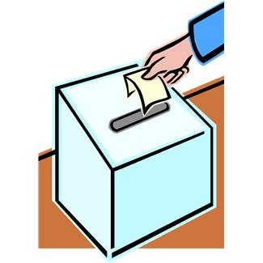

I am a (circle one): Parent Teacher/Staff Student Other

- What committee are you providing feedback for? (i.e. Boxtops, carnival, Reflections)

- Did you feel this committee/event was well executed? Why or why not?
- Did you feel that you were well informed about the committee/event? Were you comfortable being involved? Why or why not?
- What did you like about the committee/event?
- What would you like to see change next year?

- Would you like to help implement those changes, or see your ideas used?

Thank You

